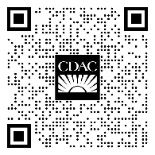
CDAC – Mon-Fri (8am-5pm) 850-434-2724
- Women with children under 6 or pregnant
- General substance abuse questions

Feel free to snap a photo of this scan code
Lakeview Center
- General information – Mon-Fri (6am-10pm) 850-469-3500
- Acute Stabilization Unit – (Crisis) (24/7 hrs.) 850-380-0967
Bridgeway – Mon-Fri (8am-5pm) 850-833-7500 after 5pm 850-376-5386
Chautauqua Health Services – (24/7) 850-892-8045

For specific information call your doctor

