Drugs and alcohol taken during pregnancy can harm your baby. Public health statistics suggest that prenatal substance exposure continues to impact a significant number of pregnancies. And yet it is a topic that we often do not talk about.  So, let’s talk about it!  Because there are things you can do to help your baby! | STATE Alliance for Drug Endangered Chidren  Phone: Local DEC Alliance  Email: Local DEC Alliance  Web: Local DEC Alliance  National Alliance for Drug Endangered Children  Learn more at nationaldec.org  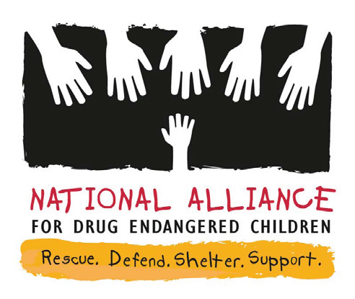 | drug & Alcohol use during pregnancy  - Let’s Talk About It
What can happen to  my baby’s body  if I use drugs/alcohol during pregnancy?  Low birthweight: Babies born weighing less than 5 pounds,  8 ounces are considered low birthweight babies. This can impact the baby’s lung function, intestines, immune system, and more.  Reduced head circumference: Some babies will have smaller than normal head size due to substance exposure in utero. This can impact brain-related and neurological functioning.  Birth defect: Birth defects change the shape or function of one or more parts of the body. They can cause problems in overall health, how the body develops, or in how the baby’s body works.  Infections (including hepatitis C, HIV, and Zika): Viruses can be spread through shared needles, sexual contact, and other ways. Moms can pass these infections to their babies during pregnancy or at birth. | Sudden infant death syndrome (also called SIDS): Using drugs during pregnancy can increase the risk of SIDS in infants.  Neonatal abstinence syndrome (also called NAS): NAS can happen when a baby is exposed to an opioid drug during pregnancy and then has signs and symptoms of abstinence after birth. Many of these signs can also be seen in babies exposed to drugs other than opioids.  Sometimes the littlest things take up the most room in your heart.  ~Winnie the pooh | What are possible long-term consequences to my baby if I use drugs or alcohol during pregnancy?  Learning & Processing Disorders  Behavioral Problems  Emotional Difficulties  Slower-than-normal Growth  Sensory Integration Deficits  Resources for Help  - Resource 1, phone number, website  - Resource 2, phone number, website  - Resource 3, phone number, website

