Handle with Care
The Children’s Advocacy Center of Bristol County has partnered with The National Alliance for Drug Endangered Children to incorporate DEC’s promising practice of Handle with Care.
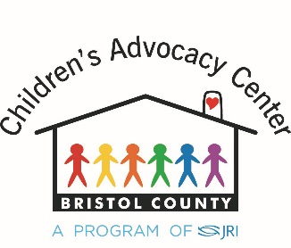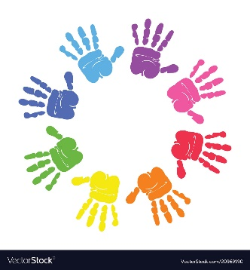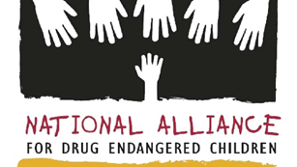
A recent national survey of the incidence and prevalence of children’s exposure to violence and trauma revealed that 60% of American children have been exposed to violence, crime, or abuse. Exposure to violence and trauma can seriously impact a child academically, emotionally and behaviorally.

A “Handle with Care” notice provides the school with a “heads up” when a child has been identified as suffering from or exposed to a traumatic event. This traumatic event could be a drug raid, separation and placement of the child, substance abuse in the home, a domestic violence situation, violence in the neighborhood, a car accident, etc. Professionals are trained to identify traumatic events as well as the children experiencing them.

In Bristol County, we ask all professionals responding to these traumatic events, to scan the QR code provided below and fill in the information needed. The form will then be sent to the appropriate school. The form will give NO details of the trauma but will state “Please Handle Johnny Smith with Care.”
ALL YOU HAVE TO DO …
- Open Camera Roll on your phone (Android/iPhone)
- Scan QR Code
- Fill out form with child’s information
- Submit
THIS FORM DOES NOT TAKE THE PLACE OF FILING A 51A
Questions? Please contact the CAC of BC by calling 508-674-6111

